Final Project #2 by Joshua Troup

Task 1: Map the tracks of each storm

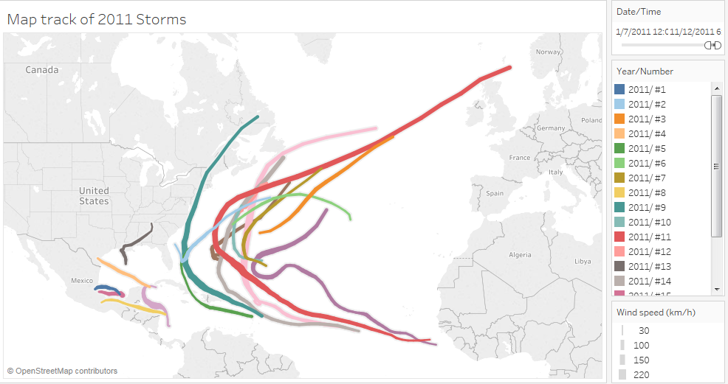

**Display of 2011 storms with wind speeds**

Task 2: Animate the storm tracking

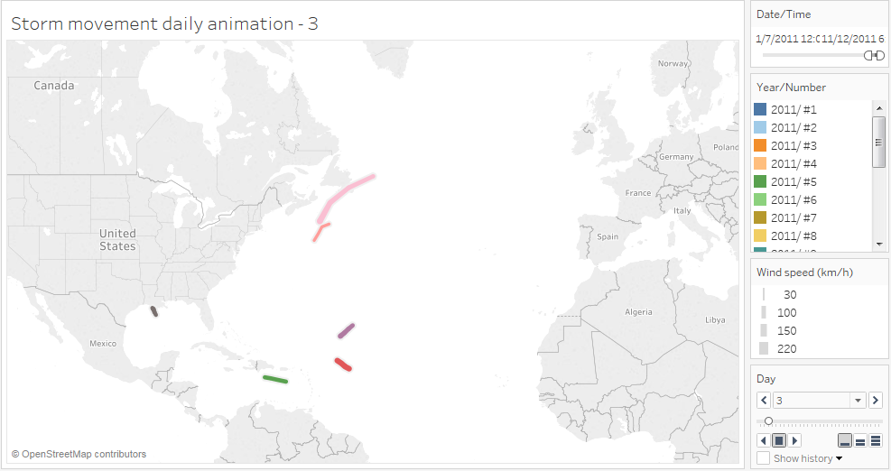

**Animated storm movement display by day**

Task 3: Wind Speeds for Each Storm over Time & create Map Control to manage views

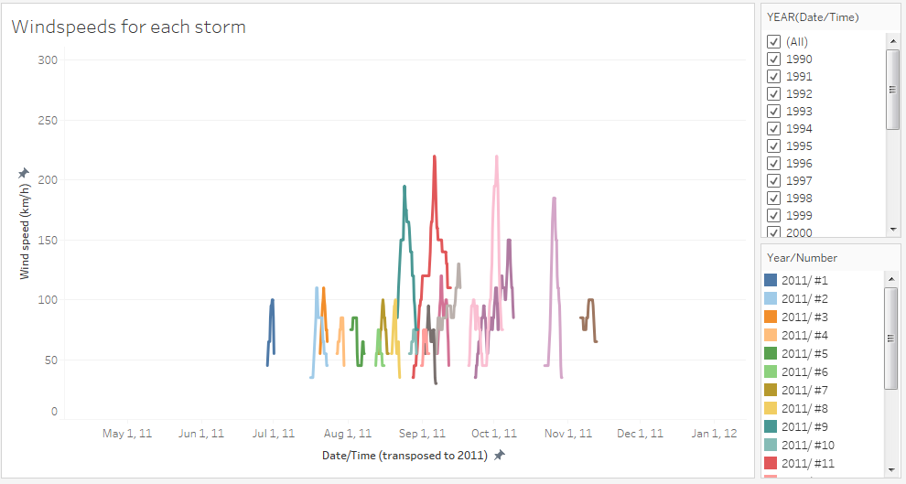

Task 4: Dashboard for Storm Tracking and Wind Speed

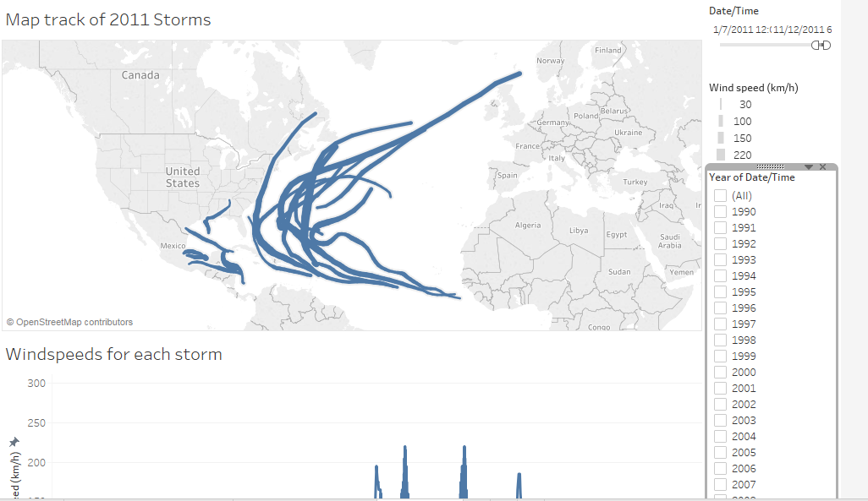

Task 5: Median Housing Sale Price

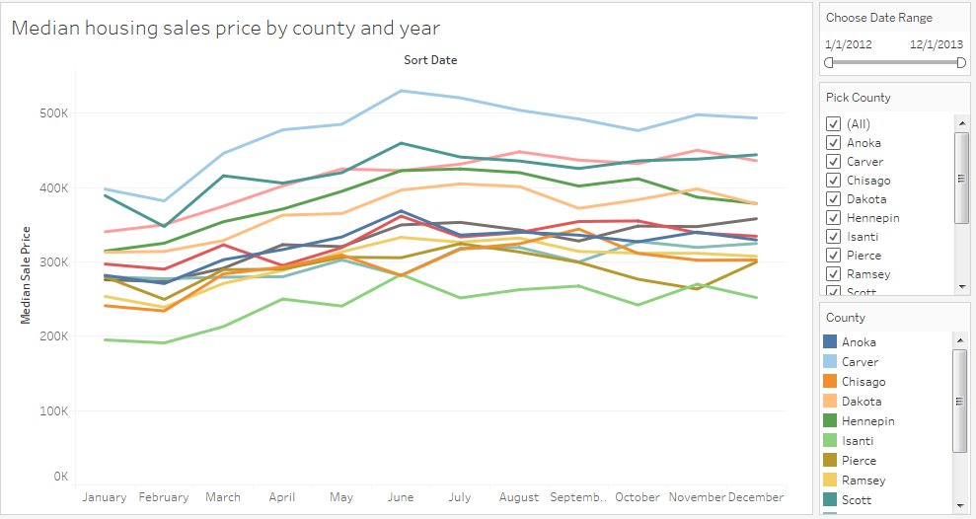

Task 6: Total House Closings (Sales) every month

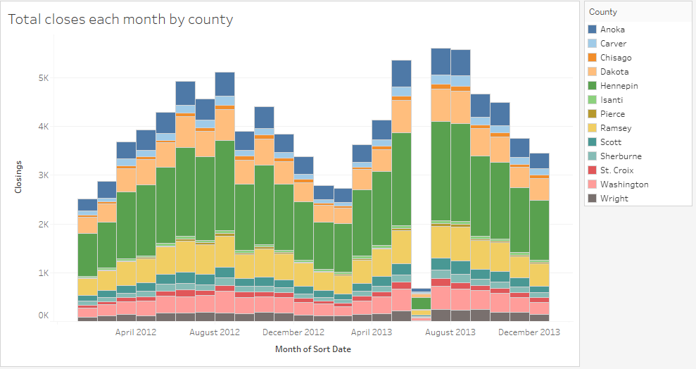

Task 7: Dashboard for Metro Housing ( Include a Global Filter)

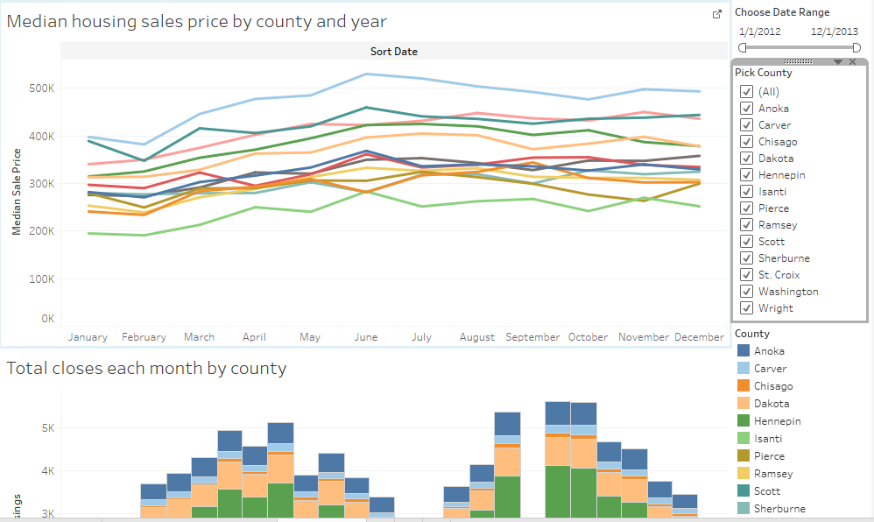

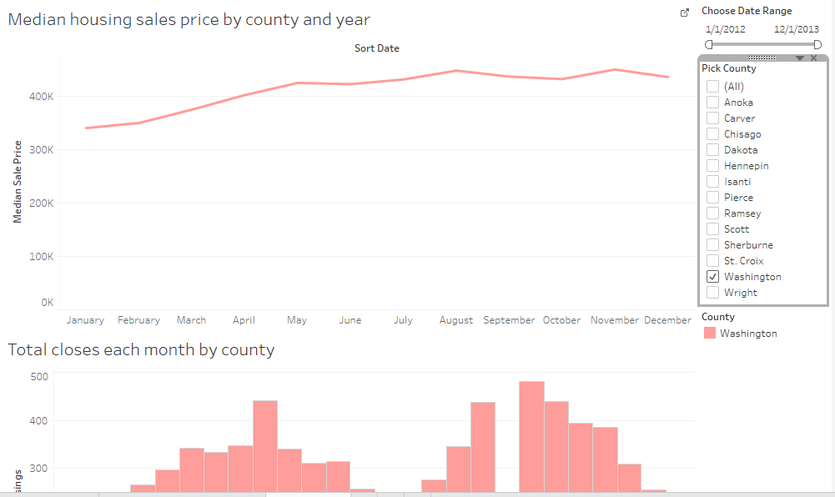

Task 8: Map View of the Metro Housing

